Querying by Orientation

Hitherto, we can see that AutoQuerying is comparing all the chips together without the knowledge of the perspective of each chip. This means that AutoQuerying is spending a lot of time comparing chips of different flanks to each other, for example, chips from the head to chips from the tail, chips from the left flank to chips from the right flank, and so on. This process is not only unnecessary, because snow leopards are not patterned symmetrically, but it also requires more processing power and time, and raises the probability of false positives.

Querying by orientation is a new feature that ECE 18.7 experimented in order to improve the performance and accuracy of AutoQuerying process. The proposed method only compares chips that are from images that capture the same flank of snow leopards. For example, chips from images that capture the left flank will be compared together, chips from images that capture the right flank will be compared together, and so on. One disadvantage is that HotSpotter would need user assistance to identify what side of the snow leopard is being shown in each image, thus reducing the autonomy of the program. However, there is an opportunity to try and train a machine learning algorithm to do this recognition.

# Classifying Images by Orientation and Number of Snow Leopards

To acquire the knowledge of the orientation of a snow leopard captured in each image, we propose adding an additional module to prompt input from user. This module could be named ClasssifyByFlank, and would be launched automatically after the user has imported all the desired images. Once all the images are successfully added into image_table.csv, ClasssifyByFlank would pop up as a window and guide the user through each of the imported images. A mock-up of this user interface is shown in Figure 1. The window would show an image alongside a prompt asking the user to choose the side of the snow leopard that the image captures. Options to choose for the sides are: left flank, right flank, front/face and back/tail. The user can choose more than one orientation if multiple angles are pictured.

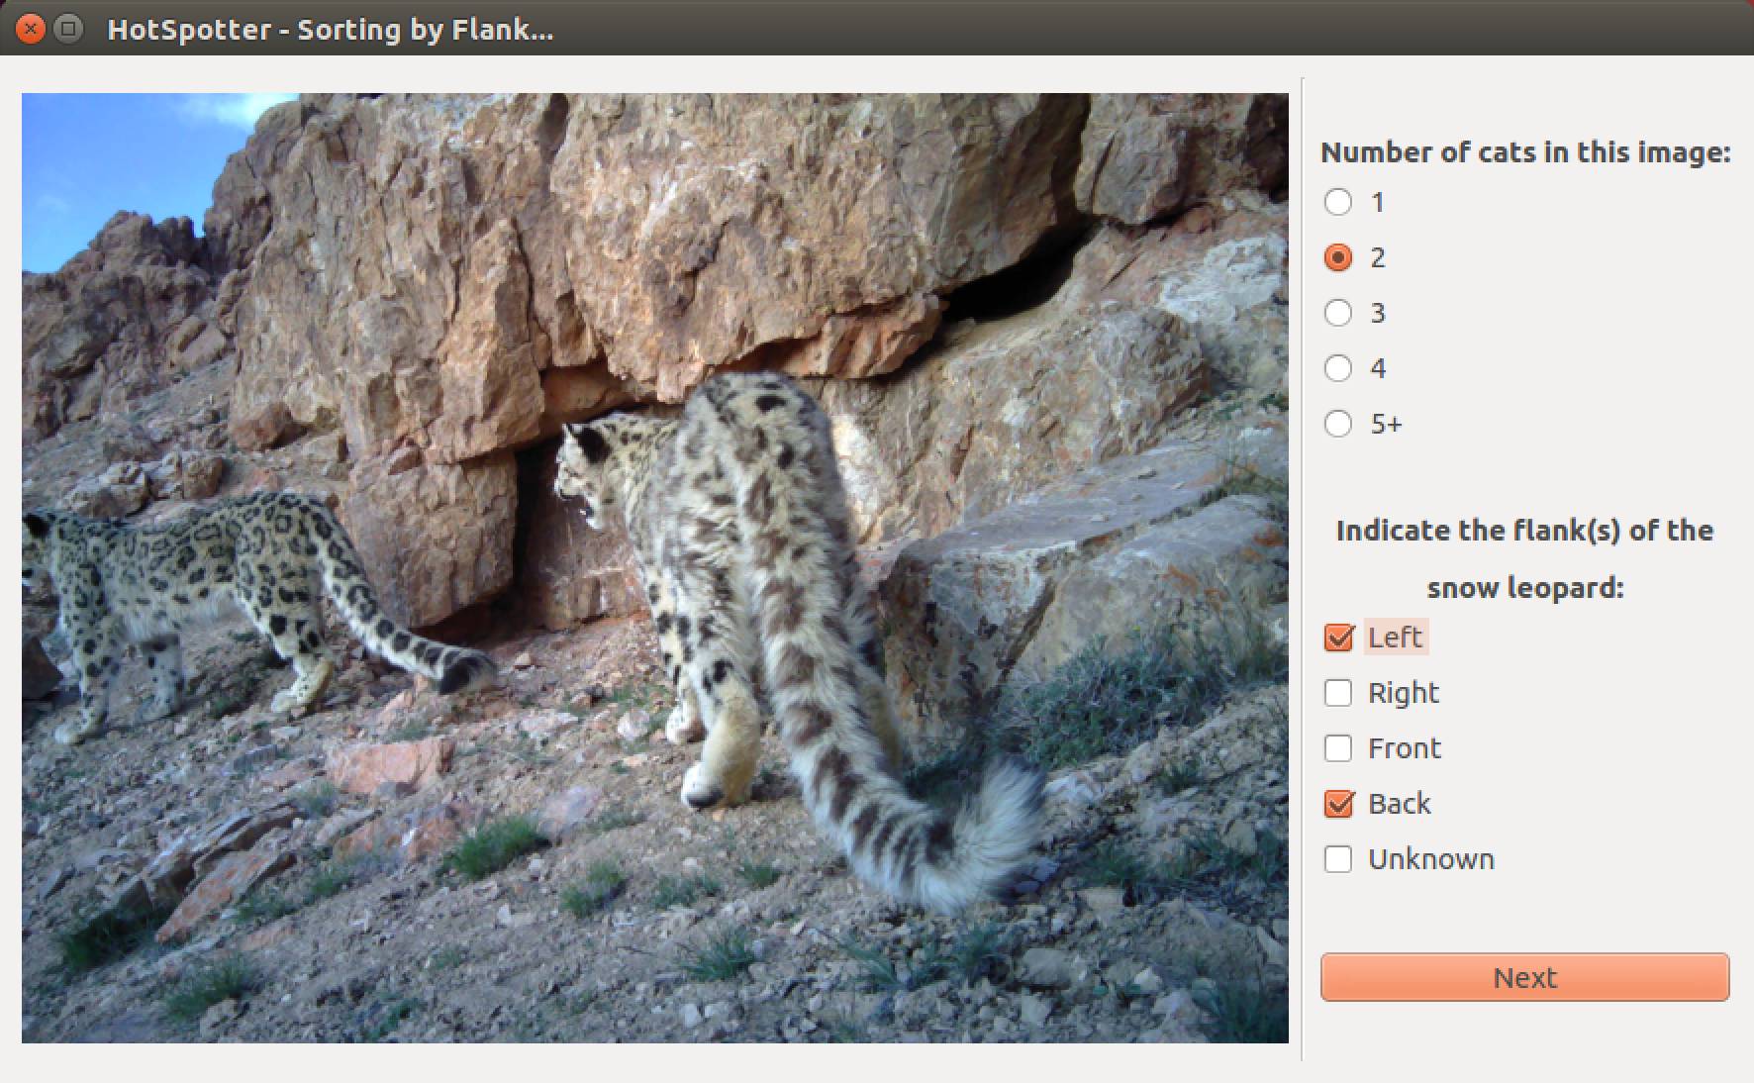

Figure 1 Pop-up window of the proposed ClassifyByFlank module.

In addition to the prompt for the flank of snow leopard shown, there would be also a prompt for the number of cats in the image. By knowing that there is more than one snow leopard in an image, we have the option to set these images aside from AutoChipping, AutoQuerying and Clustering, since these processes currently don’t work well for images with multiple snow leopards.

Once the user has checked all the imported images, ClasssifyByFlank will create two additional columns in the image_table.csv, and save the orientation labels and number of snow leopards in each image under these two columns according to data recorded from user’s input.

# Accommodate the Knowledge of Orientation into AutoChipping, AutoQuerying and Clustering

Figure 2 New strategy for accommodating flank data into existing process of HotSpotter

Figure 2 shows how current algorithm of HotSpotter can be adapted to make use of the knowledge of orientation/flank to improve the recognition accuracy. AutoQuerying can also utilize the knowledge of what side is associated with each chip to only query chips that have the same orientation label. Each time AutoQuerying compares chips of same orientation, it creates a separate score matrix and saves it to disk as scores.csv. At the end of AutoQuerying, there would be four different score matrices and four different scores.csv files, with each score matrix and scores.csv corresponding to one orientation. Clustering then clusters each of the four score matrices and identifies the number of distinct cats in each orientation set. An additional process, Cross Compare, would run once Clustering is done to link chips from different sides of the same cat together. This additional process can compare the image metadata (location, date and time) of each image associated with an identified cat in the set of each side images to the data of location, date and time of each image associated with an identified cat from the other sets of similarly orientated images. If these images were taken at the same location, and the time these images were taken differ by less than 15 minutes (time adjustable by user), these images would be grouped together and labeled as one cat. This process would allow HotSpotter to identify multiple sides of some snow leopards thus providing a more realistic population estimate